**COURSERA CAPSTONE**

**IBM Data Science Professional Capstone**

**Opening a new Shopping Mall in Liverpool, UK**

Student: David Kljajo

September, 2020

**Introduction**

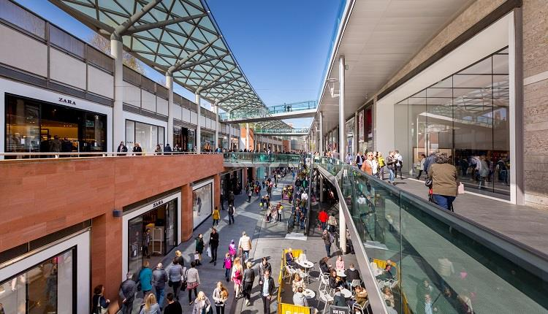

For many local people and especially tourists, visiting shopping malls is great enjoy and relaxing. They can buy almost anything they wish in one place, go to restaurants or go to cinema. Opening shopping malls, allows property developers to earn consistent rental income.

Opening shopping malls requires serious consideration and takes many factors that makes the whole process more complex.

Location of shopping mall is one of the most important decisions and can determine how successful the project will be; and we will examine the city clusters to decide where the place for shopping mall will be the best for the process of building.

**Business problem**

The goal of this project is to analyze and decide where to build a shopping mall in Liverpool (United Kingdom). Using Data Science and Machine Learning algorithms, this project try to answer the question is it worth building a new Shopping Mall in Liverpool and especially determine where to build it.

**Data**

* List of neighbors in Liverpool.
* Latitude and longitude of these neighbors.
* Venue data, especially the data about shopping malls.